Municipal Officers’ Notice of Public Hearing on Secret Ballot Referendum Issue

Notice is hereby given that the Municipal Officers of the Town of SMITHFIELD
will hold a public hearing on MAY 7, 2024 at MUNICIPAL BUILDING, 926 VILLAGE RD. at 6:00 PM in said Town to hear public comment on the following:

TO SEE IF THE TOWN WILL VOTE TO RAISE AND APPROPRIATE $118,000.00 TO REPLACE THE MUNICIPAL BUILDING ROOF WITH METAL.

Municipal Officers’ Return
SMITHFEILD, Maine
Pursuant to 30-A M.R.S. § 2528(5), we have this day, being at least seven days before the hearing, notified the inhabitants of said Town of a public hearing, to be held at the time and place, and for the purposes stated above, by posting a copy of said notice at the following public and conspicuous places in said Town/City.
Dated: APRIL 19, 2024.
Attest:
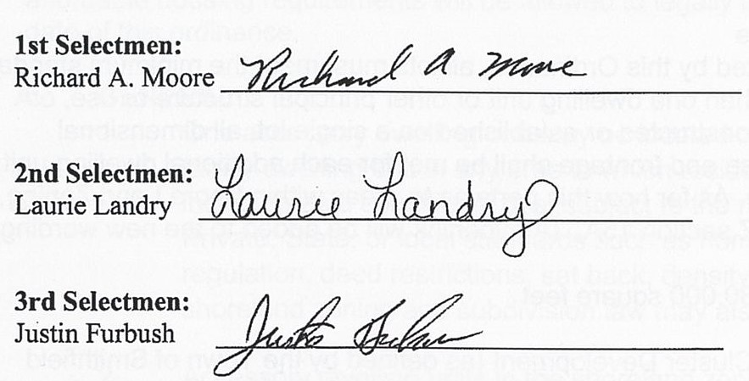

Municipal Officers

